## **Rev those engines… It's Nintendo Society News Time!**

It’s been a busy few weeks with exams and all that, but look we’ve switched the logo in celebration of a new game!

And with that, here are this week's announcements:

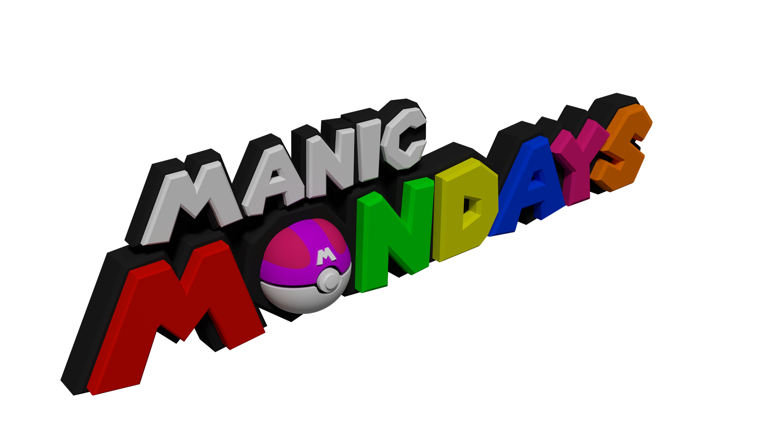

### **Monday 8/5, R1.03, 6pm onwards**

Mario Kart 8 Deluxe has sold over 1 million copies, and we have 2 of them! So come experience the definitive version of Mario Kart alongside the revamped (and very much improved) battle mode!

There may also be a spot of Super Mario Sunshine Multiplayer!



### **Wednesday 10/5, R1.04, 2pm onwards**

Our weekly Smash event returns! This time with mods! Come along to destress from term 3 revision and have fun!

---------------------------------------------------------------------------------------

Well then, folks, until next time, staaaay fresh!

And Happy Gaming! :D

Timothy Sit

Nintendo Society President

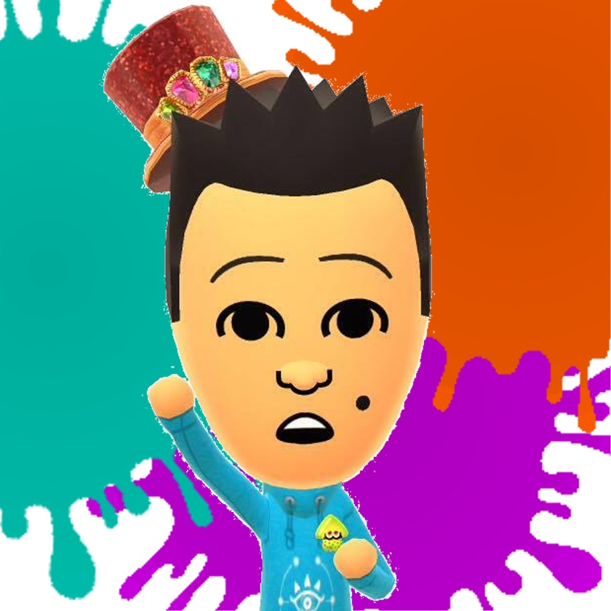

---------------------------------------------------------------------------------------

### **Find us on Social Media:**

Join our Facebook group:<https://www.facebook.com/groups/warwicknintendo/>

Follow our Twitter:<https://twitter.com/warwicknintendo>

Join our Discord Chat:<https://discordapp.com/invite/Rf6QyfG>

Subscribe to our YouTube:<https://www.youtube.com/channel/UCzO_bZNfQDCAQa_zkEUgGVg>